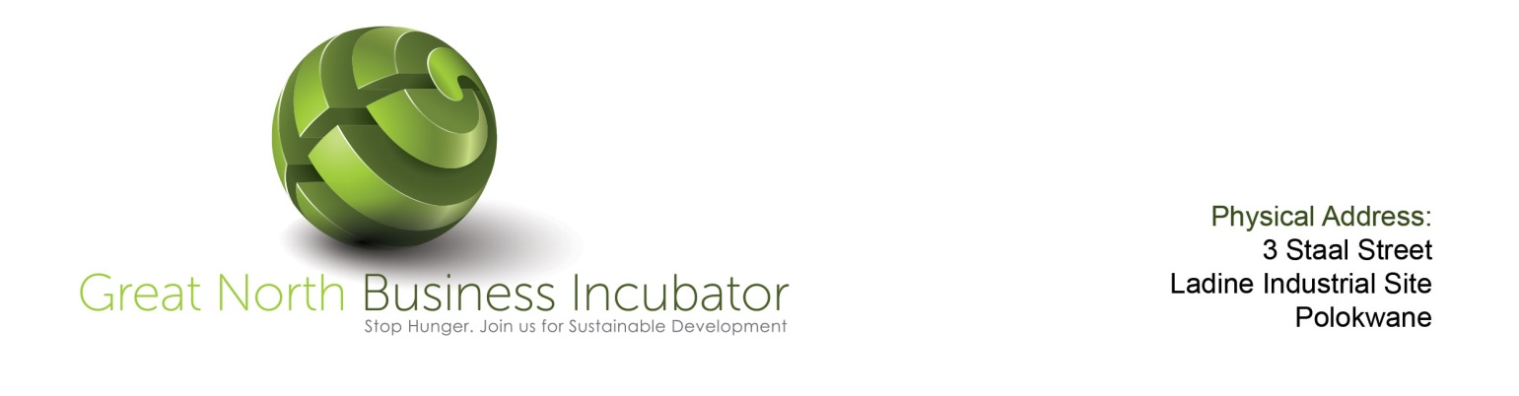
Preliminary Application
Primary Information
Date of Application:

Applicant Name:

Street Address:

Postal Address:

Telephone: Fax:

Cell Number: Email:

Project/Company Name: Web Site Address (if applicable)

Project/ Company Information
Describe your products or services?

Describe the market for your products or services?

How will your product or service generate revenue?

Do you have a team in place for your business? ☐Yes ☐No
If yes, please provide names and positions:

Do you have a business plan? ☐Yes ☐No

Did you establish a company? ☐Yes Date of Incubation:
☐No
Major Partners/ Shareholders

What is the current stage of development of your product or service offering?
☐Idea ☐Ready to Launch
☐Development ☐ Being Sold
Did you start generating any revenue? ☐Yes ☐No

If no, how much time does your business need to start generating revenue?

Logistical Needs
Are you interested in locating your business at the Incubator? ☐ Yes ☐No
If yes, how many team members do you expect to have?
Now: After 6 months: After 12 months:
Support Needs
Are you interested in benefiting from the support services at the Incubator?

If yes which of the following services are of interest to you?

Strategy Planning ☐Yes ☐No
Financial Planning ☐Yes ☐No
Contacts and Introductions ☐Yes ☐No
Partnerships Development ☐Yes ☐ No
Fund Raising ☐Yes ☐No
Recruitment ☐Yes ☐No
Marketing Services ☐Yes ☐No
Legal Services ☐Yes ☐No
Accounting Services ☐Yes ☐No
Funding Needs
Have you raised any funding for your company? ☐Yes ☐No

Do you plan to raise any funding for your company? ☐Yes ☐No

General
If you were referred to us, please provide a short explanation here.

Other
Please include any comments or further information that you wish to communicate to us.

